**Lexical-grammar test**

*(Unit 10, Destination B2)*

***Прочитайте текст. Выберите один из предложенных вариантов ответа***

Sarah always wanted to 1) … down in the countryside, where the pace of life meets with 2) … from her family. She never thought she'd 3) … in love with someone so different from her. Eric, her city-loving partner, often 4) … an argument about moving. Although he feels 5) … into this decision, he knows they'll find happiness together.

1. 1) settle 2) decide 3) fix 4) set 5) resolve
2. 1) opinion 2) regard 3) approval 4) respect 5) favour
3. 1) decrease 2) fall 3) reduce 4) drop 5) contract
4. 1) suffers 2) misplaces 3) keeps 4) loses 5) wins
5. 1) powered 2) forced 3) looked 4) put 5) strengthened

***Прочитайте текст. Заполните каждый из пропусков только ОДНИМ предлогом, подходящим по смыслу***

Travelling solo can be an exhilarating experience, and many people seek to be independent 1) … the usual group dynamics. One might initially object 2) … the idea due to safety concerns, but let me convince you of its value. During a solo journey, you learn to rely 3) … yourself and make decisions that you truly approve 4) … .

Take Lisa, for example. She recently embarked on a trip alone and when people asked 5) … her journey, she shared stories of self-discovery and personal growth. There was an unexpected attack 6) … her confidence when she got lost in a new city, but overcoming that made her stronger.

While some agree 7) … her decision to travel alone, others might ban 8) … such adventures, thinking it's risky. However, Lisa believes that it’s crucial not to feel forced 9) … societal norms and to embrace independence. Ultimately, travelling solo brings about a new awareness, helping you grow in ways you might never imagine.

***Поставьте фразовый глагол из предложенных ниже глаголов***

*settle down, stand up for, make up with, get on with, put down, look up,*

*grow up, taken aback, fall out*

In the small town of Eldenbury, Amelia had always admired her brother, Jack. She would often 1) … to him, especially during their adventurous outings to the nearby forest. However, as they began to 2) … , things started to change. They would often 3) … over trivial matters, sometimes going days without speaking.

One sunny afternoon, they sat by the river, where Jack was unexpectedly 4) … by Amelia’s maturity. “I think it’s time we 5) … each other,” Amelia suggested. Jack nodded, realising that their petty squabbles shouldn’t define them. They both remembered the countless days spent playing and decided it was more important to 6) … each other than to harbour grudges.

As they returned home, Amelia shared a story about how she had to 7) … her friend at school, an act that Jack secretly admired but would often 8) … as insignificant. He realised how unfair he had been, apologising for never acknowledging Amelia’s courage. This moment helped both siblings bring up their concerns and aspirations for the future, for they both knew they would soon need to 9) … into their own lives.

***Прочитайте предложения. Заполните пропуски ОДНИМ словом, подходящим по смыслу- , сразу для двух предложений. Запишите слово в бланке ответов только ОДИН раз***

1. Jenny has always found it easy to make … at school.

He participates in class discussions and has true …

1. I always have a … about climbing a mountain.

I had a … about you last night.

1. Don't … promises you can't keep.

After a few unsuccessful attempts to … friends, an innocent misunderstanding shifts Jonathan’s fortunes.

1. He sounded so upset that Leah started to… pity on him.

You ought to … care of yourself.



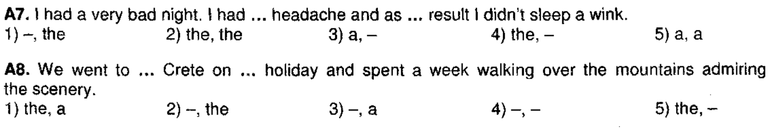

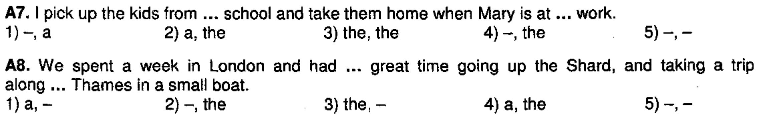

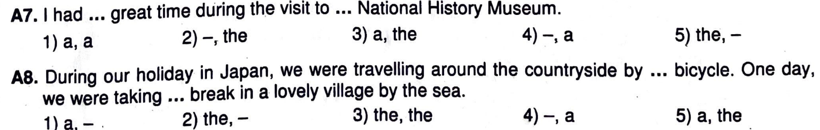

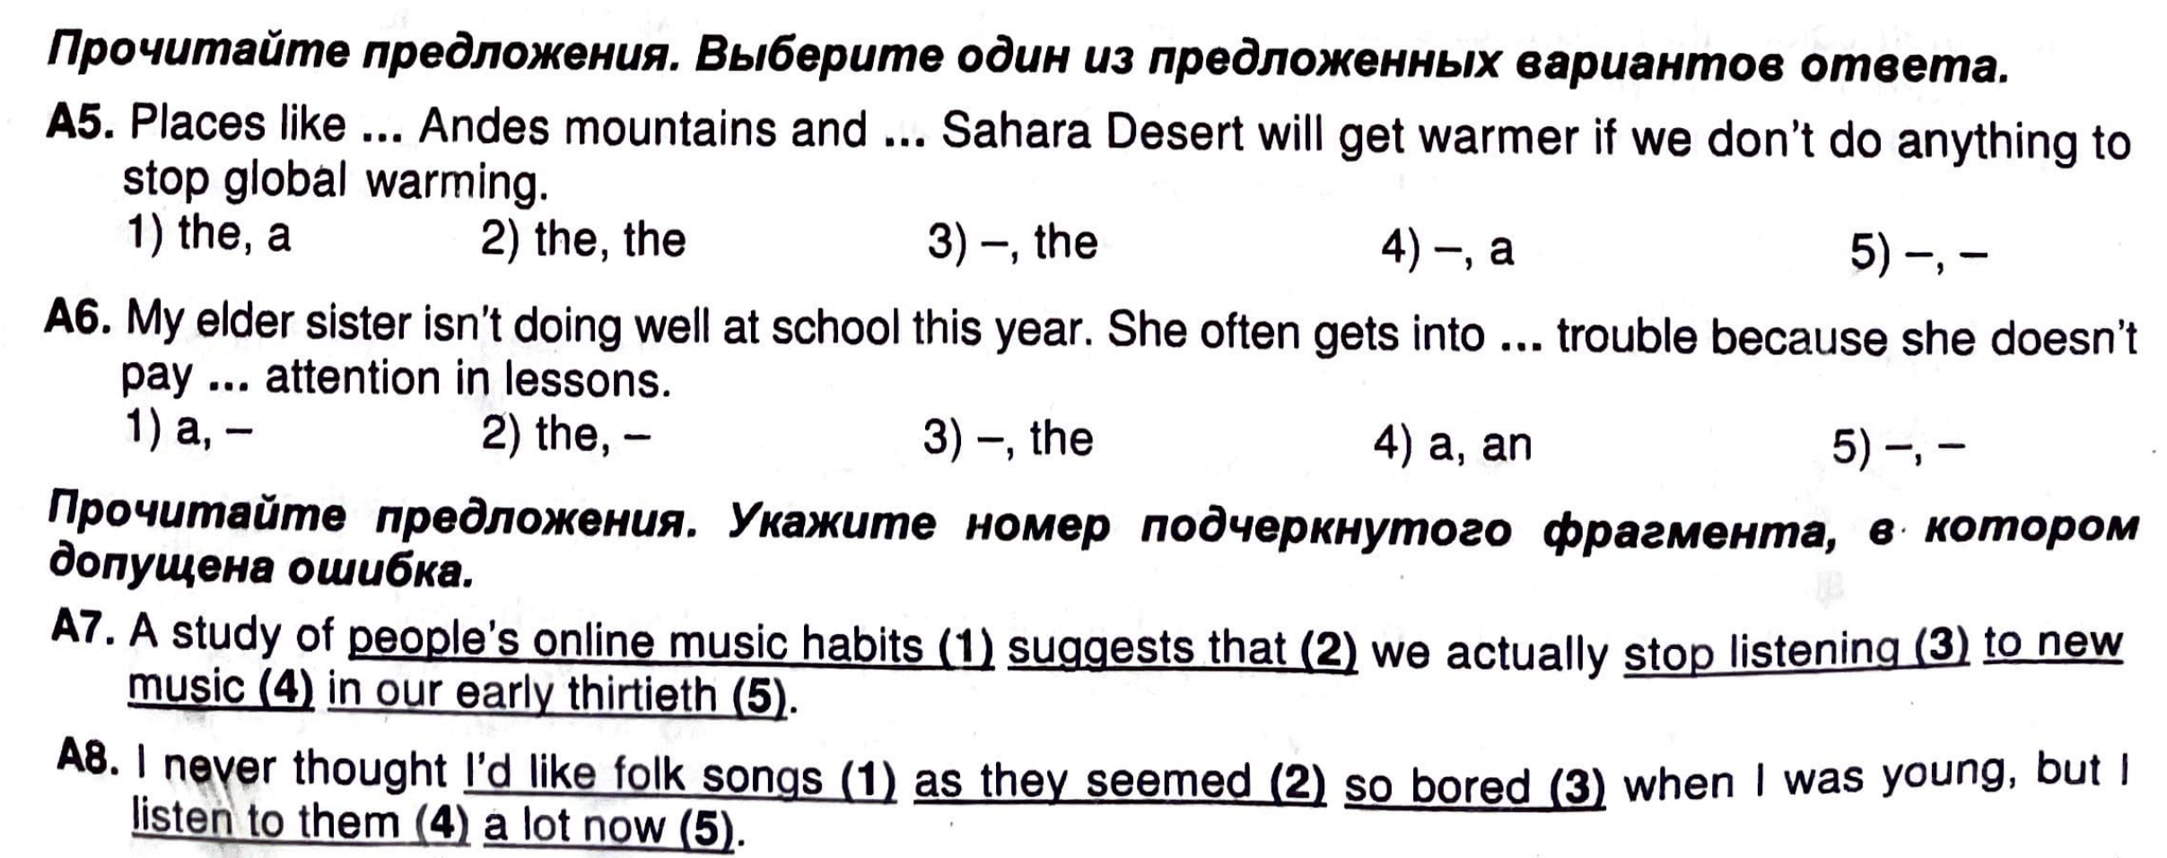

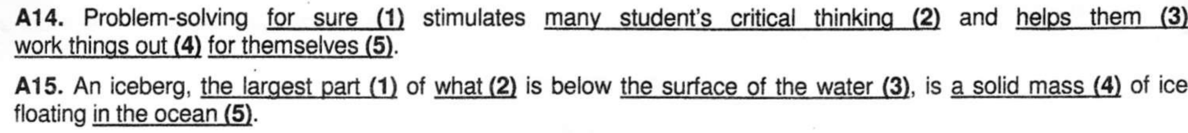

**Lexical-grammar test KEYS**

*(Unit 10, Destination B2)*

***Прочитайте текст. Выберите один из предложенных вариантов ответа***

Sarah always wanted to 1) … down in the countryside, where the pace of life meets with 2) … from her family. She never thought she'd 3) … in love with someone so different from her. Eric, her city-loving partner, often 4) … an argument about moving. Although he feels 5) … into this decision, he knows they'll find happiness together.

1. 1) settle 2) decide 3) fix 4) set 5) resolve
2. 1) opinion 2) regard 3) approval 4) respect 5) favour
3. 1) decrease 2) fall 3) reduce 4) drop 5) contract
4. 1) suffers 2) misplaces 3) keeps 4) loses 5) wins
5. 1) powered 2) forced 3) looked 4) put 5) strengthened

***Прочитайте текст. Заполните каждый из пропусков только ОДНИМ предлогом, подходящим по смыслу***

Travelling solo can be an exhilarating experience, and many people seek to be independent from the usual group dynamics. One might initially object to the idea due to safety concerns, but let me convince you of its value. During a solo journey, you learn to rely on yourself and make decisions that you truly approve of.

Take Lisa, for example. She recently embarked on a trip alone and when people asked about her journey, she shared stories of self-discovery and personal growth. There was an unexpected attack on her confidence when she got lost in a new city, but overcoming that made her stronger.

While some agree with her decision to travel alone, others might ban from such adventures, thinking it's risky. However, Lisa believes that it’s crucial not to feel forced into societal norms and to embrace independence. Ultimately, travelling solo brings about a new awareness, helping you grow in ways you might never imagine.

***Поставьте фразовый глагол из предложенных ниже глаголов***

*settle down, stand up for, make up with, get on with, put down, look up,*

*grow up, taken aback, fall out*

In the small town of Eldenbury, Amelia had always admired her brother, Jack. She would often look up to him, especially during their adventurous outings to the nearby forest. However, as they began to grow up, things started to change. They would often fall out over trivial matters, sometimes going days without speaking.

One sunny afternoon, they sat by the river, where Jack was unexpectedly taken aback by Amelia’s maturity. “I think it’s time we make up with each other,” Amelia suggested. Jack nodded, realising that their petty squabbles shouldn’t define them. They both remembered the countless days spent playing and decided it was more important to get on with each other than to harbour grudges.

As they returned home, Amelia shared a story about how she had to stand up for her friend at school, an act that Jack secretly admired but would often put down as insignificant. He realised how unfair he had been, apologising for never acknowledging Amelia’s courage. This moment helped both siblings bring up their concerns and aspirations for the future, for they both knew they would soon need to settle down into their own lives.

***Прочитайте предложения. Заполните пропуски ОДНИМ словом, подходящим по смыслу- , сразу для двух предложений. Запишите слово в бланке ответов только ОДИН раз***

1. Jenny has always found it easy to make friends at school.

He participates in class discussions and has true friends

1. I always have a dream about climbing a mountain.

I had a dream about you last night.

1. Don't make promises you can't keep.

After a few unsuccessful attempts to make friends, an innocent misunderstanding shifts Jonathan’s fortunes.

1. He sounded so upset that Leah started to take pity on him.

You ought to take care of yourself.