**Lexical-grammar test**

*(Unit 8, Destination B2)*

1. ***Прочитайте текст. Заполните каждый из пропусков только ОДНИМ предлогом, подходящим по смыслу***

Every day, I like to fill 1. … my diary, as it helps me keep track of thoughts and dreams. Recently, I've been struggling to see 2. … some decisions I made, and it's rather discouraging. I tried to look 3. … in a guide for advice, hoping it might inform 4. … the right choices to make.

Last week, I was thrilled to hear 5. … an old friend, who was keen to comment 6. … the very same issues I've been facing. Our conversation seemed to correspond 7. … many of the things I'd been thinking, which was quite a relief.

However, my friend shared an important perspective: sometimes, there's no point 8. … worrying too much. Life can be unpredictable, and we should learn to embrace that. I was rather surprised 9. … the peace this viewpoint brought me, but it was certainly much needed.

1. ***Прочитайте текст. Выберите один из предложенных вариантов ответа***

It's easy to 1. … for granted the small things in life. We often assume the sun will shine and that a smile from a stranger will make no 2. … . However, it's the little things that can truly stand out and catch us by 3. … . Recently, a friend asked me to 4. … a description of my perfect day. I paused, realising I had never thought about it in detail. As I began to 5. … on each aspect, from the aroma of my morning coffee to the sound of laughter in the park, I understood that these simple pleasures were the essence of joy. It's in recognising these moments that we truly appreciate their value.

1. 1) take 2) give 3) make 4) get 5) receive
2. 1) use 2) sure 3) difference 4) doubt 5) sense
3. 1) shock 2) surprise 3) chance 4) discovery 5) mistake
4. 1) make 2) find 3) get 4) give 5) take
5. 1) remark 2) comment 3) maintain 4) note 5) discuss
6. ***Прочитайте текст. От приведенных в скобках слов образуйте ОДНОКОРЕННЫЕ слова таким образом, чтобы они грамматически и лексически соответствовали содержанию текста. Заполните пропуски полученными словами. помните, что заданную форму слова необходимо изменить***
7. In today's world, the role of 1) … (journal) is becoming more critical than ever. With so many people feeling uninformed or disconnected from important issues, 2) … (write) and 3) … (politics) are stepping up to provide essential 4) … (communicate). This is an exciting time for those who are excited about making an impact. Whether you're writing articles or engaging in public 5) … (discuss), your voice can 6) … (power) others to stay 7) … (inform) and active. Many people are 8) … (convince) that thoughtful discourse can lead to meaningful change. So when the next big 9) … (announce) is made, take the opportunity to explore the full story and share your insights with those around you. Your contribution could provide the clarity that others need to stay engaged.
8. In today's world, the line between 1) … (humour) and serious content has become increasingly blurred, especially in 2) … (edit) articles. With so much 3) … (inform) available, it's almost 4) … (belief) how quickly stories spread. The challenge for journalists is to provide 5) … (inform) pieces while maintaining their integrity. Many 6) … (second) sources are written with bias, making it hard to know what to believe. The role of 7) … (edit) has never been more crucial; they must ensure that each article is 8) … (convince) yet accurate. In the face of 9) … (politics) upheaval, editors often find themselves in precarious positions, balancing truth with public interest. It's clear that the way we consume news is changing rapidly, and adapting is key to keeping up with this unbelievable pace.
9. ***Прочитайте предложения. Заполните пропуски ОДНИМ словом, подходящим по смыслу- , сразу для двух предложений. Запишите слово в бланке ответов только ОДИН раз***
10. … out for her. She plays dirty.

The police arrived to keep … on the mouth of the tunnel.

1. Staff meetings … place once a week.

I felt a need to … control of the situation.

1. The book … a positive influence on me.

The hotel room … a gorgeous view.

1. ***Прочитайте предложения. Укажите номер подчеркнутого фрагмента, в котором, допущена ошибка.***









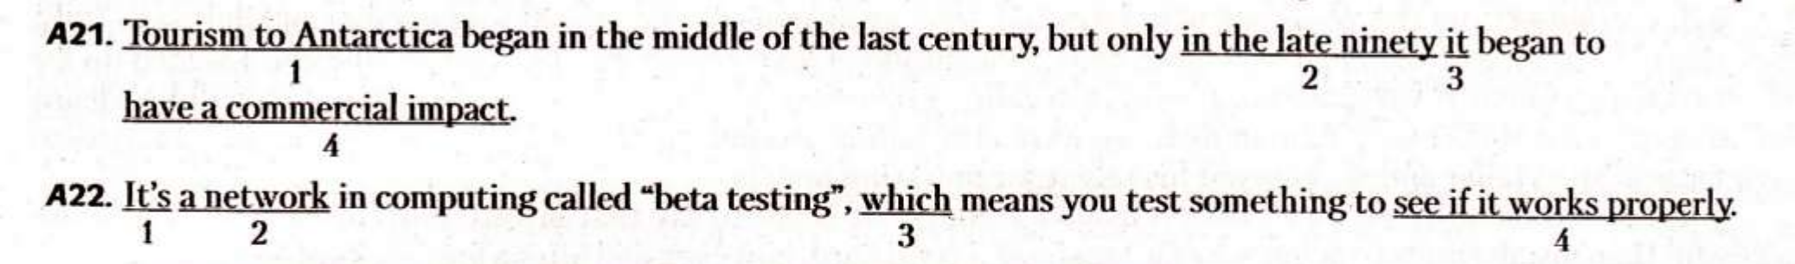







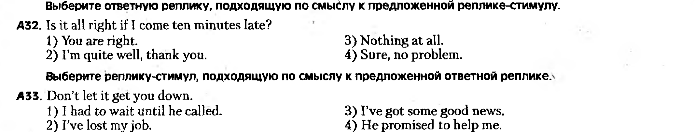

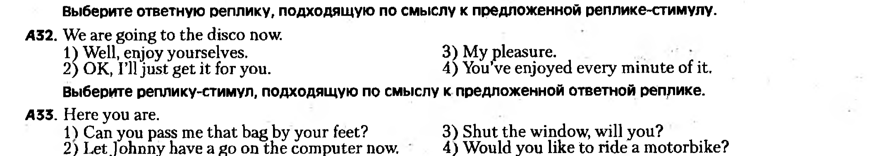

**Lexical-grammar test KEYS**

*(Unit 8, Destination B2)*

***Прочитайте текст. Заполните каждый из пропусков только ОДНИМ предлогом, подходящим по смыслу***

Every day, I like to fill 1. in my diary, as it helps me keep track of thoughts and dreams. Recently, I've been struggling to see 2. through some decisions I made, and it's rather discouraging. I tried to look 3. up in a guide for advice, hoping it might inform 4. about the right choices to make.

Last week, I was thrilled to hear 5. from an old friend, who was keen to comment 6. on the very same issues I've been facing. Our conversation seemed to correspond 7. with many of the things I'd been thinking, which was quite a relief.

However, my friend shared an important perspective: sometimes, there's no point 8. in worrying too much. Life can be unpredictable, and we should learn to embrace that. I was rather surprised 9. by the peace this viewpoint brought me, but it was certainly much needed.

***Прочитайте текст. Выберите один из предложенных вариантов ответа***

It's easy to 1. … for granted the small things in life. We often assume the sun will shine and that a smile from a stranger will make no 2. … . However, it's the little things that can truly stand out and catch us by 3. … . Recently, a friend asked me to 4. … a description of my perfect day. I paused, realising I had never thought about it in detail. As I began to 5. … on each aspect, from the aroma of my morning coffee to the sound of laughter in the park, I understood that these simple pleasures were the essence of joy. It's in recognising these moments that we truly appreciate their value.

1. 1) take 2) give 3) make 4) get 5) receive
2. 1) use 2) sure 3) difference 4) doubt 5) sense
3. 1) shock 2) surprise 3) chance 4) discovery 5) mistake
4. 1) make 2) find 3) get 4) give 5) take
5. 1) remark 2) comment 3) maintain 4) note 5) discuss

***Прочитайте текст. От приведенных в скобках слов образуйте ОДНОКОРЕННЫЕ слова таким образом, чтобы они грамматически и лексически соответствовали содержанию текста. Заполните пропуски полученными словами. помните, что заданную форму слова необходимо изменить***

In today's world, the role of journalism is becoming more critical than ever. With so many people feeling uninformed or disconnected from important issues, writers and politicians are stepping up to provide essential communication. This is an exciting time for those who are excited about making an impact. Whether you're writing articles or engaging in public discussions, your voice can empower others to stay informed and active. Many people are convinced that thoughtful discourse can lead to meaningful change. So when the next big announcement is made, take the opportunity to explore the full story and share your insights with those around you. Your contribution could provide the clarity that others need to stay engaged.

In today's world, the line between humorous and serious content has become increasingly blurred, especially in editorial articles. With so much information available, it's almost unbelievable how quickly stories spread. The challenge for journalists is to provide informative pieces while maintaining their integrity. Many secondary sources are written with bias, making it hard to know what to believe. The role of editors has never been more crucial; they must ensure that each article is convincing yet accurate. In the face of political upheaval, editors often find themselves in precarious positions, balancing truth with public interest. It's clear that the way we consume news is changing rapidly, and adapting is key to keeping up with this unbelievable pace.

***Прочитайте предложения. Заполните пропуски ОДНИМ словом, подходящим по смыслу, сразу для двух предложений. Запишите слово в бланке ответов только ОДИН раз***

1. Watch out for her. She plays dirty.

The police arrived to keep watch on the mouth of the tunnel.

1. Staff meetings take place once a week.

I felt a need to take control of the situation.

1. The book has a positive influence on me.

The hotel room has a gorgeous view.