**Lexical-grammar test**

1. ***Find the extra word in each line***

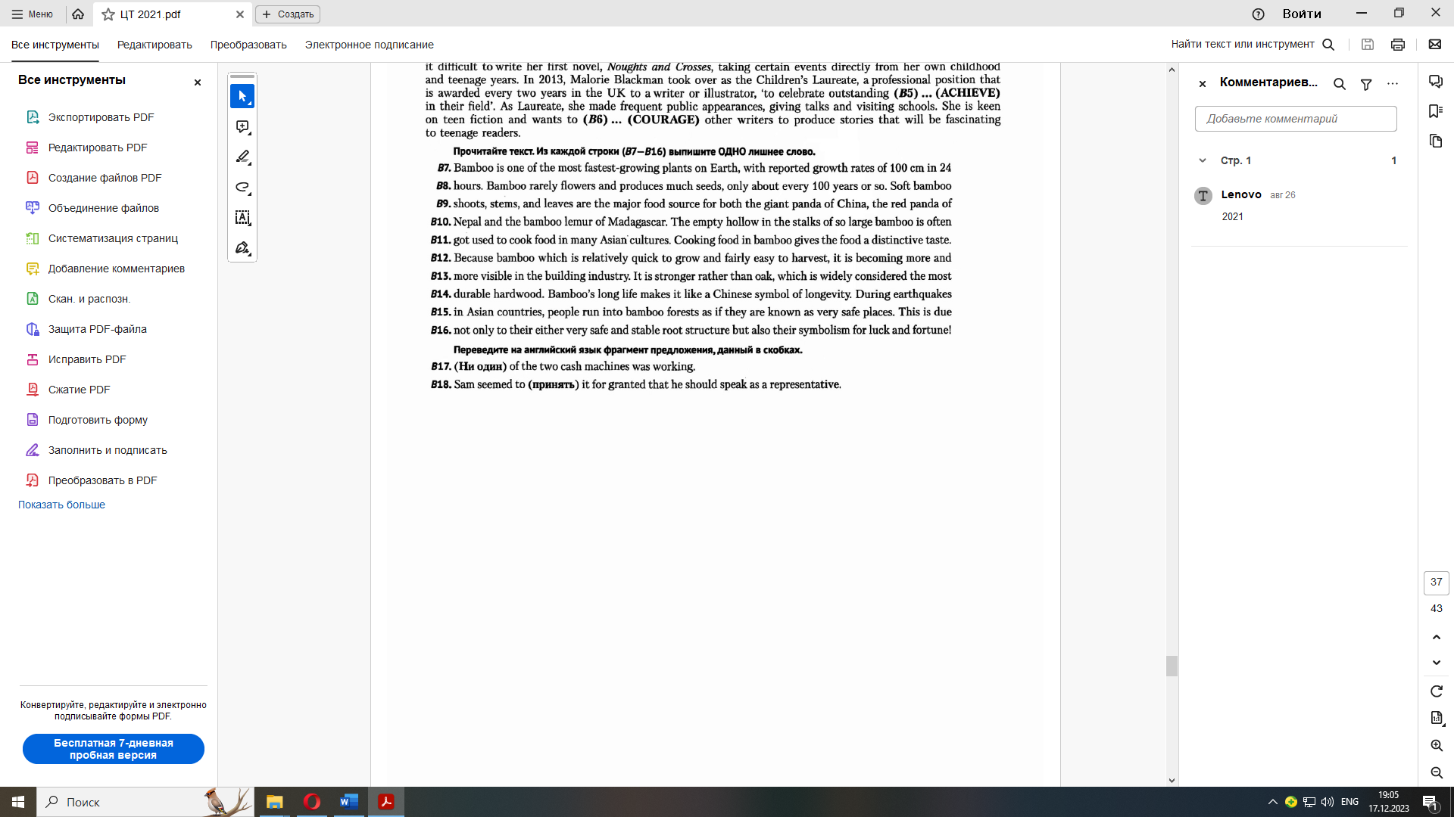

1. ***Complete the sentences by changing the form of the word***
2. Their … is very basic. know
3. The hockey team received a gold … at the Olympics. medal
4. His father gives him a monthly … of £200. allow
5. I no longer wish to be … with people like him. associate
6. There were more than 500 … in the race. compete
7. For me, music is a great source of … enjoy
8. The car comes … with power windows. equip
9. I'm sorry for your … lose
10. His essay was clearly and … written. interest
11. It was my … to be chosen first. fortune
12. ***Fill in the articles where necessary***
13. I don’t have … mind to do this task.
14. Geraldine has diligently kept … diary since she was 15.
15. Hegel's philosophy will be examined in … detail in Chapter 4.
16. Today's economic problems pale in … comparison with those of the 1930s.
17. The furniture was of little worth since it was in such … bad condition.
18. She will succeed in … end.
19. We'll go for… walk and then will have our dinner.
20. I have … cold right now so I can't smell.
21. Did you have … good time at the party?
22. Big hats *are* ***no longer*** *(больше не)* in … fashion.
23. Pandas could become extinct in … wild.
24. ***Complete the sentence using any correct word***
25. He was in full control … the situation.
26. … do you work for?
27. … you feel all right?
28. He is in favour …gradual, evolutionary social change.
29. Hold … while I find a pen.
30. You need that money … than I do.
31. I'd like to stay at home this evening rather … go out.
32. … of my friends phone me any more.
33. Her sister is … more social than she is.
34. He is … in Paris or in London.
35. ***Write the word that can suit both sentences***
36. I won't … up with any more broken promises from him.

I'm going to … an end to the corruption in this department once and for all!

1. Can I trust you to … a secret?

The electronic catalogue allows librarian to … a register of readers and to obtain information about current debt.

1. 'Would you … me a hand?' ' I'd be glad to.'

In spite of their troubles they never … up hope.

1. I'd better go and … ready.

She's trying to … a job in New York.

1. She was unashamed to … the truth.

It's a sin to … a lie.

1. … out of sight until I tell you it's OK to come out.

I had to walk fast to … up with him.

1. ***Complete the sentence with the correct word***
2. I have been held … (up, on, out) in traffic.
3. We're going to be late if that slowpoke doesn't … (keep, hold, hurry) up.
4. The copy closely matches the … (authentic, original)
5. There is no proof that the document is … (authentic, original)
6. He was wearing a … (false, artificial, fake, unreal, untrue, different, imitation, counterfeit) mustache.
7. Our products are free from … (false, artificial, fake, unreal, untrue, different, imitation, counterfeit) additives.
8. Children learn a lot by … (false, artificial, fake, unreal, untrue, different, imitation, counterfeit)
9. Our trip to Disneyland was … (false, artificial, fake, unreal, untrue, different, imitation, counterfeit)
10. Please decide whether the following statements are true or … (false, artificial, fake, unreal, untrue, different, imitation, counterfeit)
11. On closer inspection the money turned out to be … (false, artificial, fake, unreal, untrue, different, imitation, counterfeit)
12. He made … … (false, artificial, fake, unreal, untrue, different, imitation, counterfeit) statements to the press.
13. She was struggling to (keep, hold) back the tears.